Candidate Information Pack
Senior Economist

Message from the Chief Executive

Dear Applicant

Thank you for your interest in working for Learning and Work Institute.

We are at the cutting edge of debates on meeting the skills needs of the future, helping people adapt to the changing world of work, and ensuring as many people as possible benefit from learning.

This year marks our centenary: we have a proud history and bright future. Our work covers the full span of learning, skills and employment policy and delivery. It ranges across analysis, research, policy, development, evaluation and innovation. Our focus is on having an impact and punching above our weight.

The role of Senior Economist is a key one within Learning and Work Institute, with responsibility for leading quantitative analyses in the fields of employment, labour markets, education and skills. This role will have a particular focus on designing and leading high quality impact evaluations, helping us generate evidence on what works in employment and skills to deliver better outcomes.

The ideal candidate will bring an in-depth understanding of labour market economics, advanced econometric skills, a track record of designing and delivering projects, and an interest in the policy context for learning, skills and employment.

The focus of all we do is on making a difference – it is one of the many reasons why working here is so rewarding.

Learning and Work Institute is a Silver Investors in People Award holder, so our people matter. You will be a confident people manager, who can empower and inspire teams to deliver and innovate.

You would also bring excellent networking skills with experience of building relationships with a wide range of stakeholders including politicians and policymakers to make sure we maximise our impact and make a difference.

As a key member of the team, you will be joining the Institute at a positive time when the issues of learning, skills and employment have never been more relevant.

For an informal and confidential discussion about this opportunity, please contact our advising consultants at GatenbySanderson, Hilda Gjika or Enfys Evans. Contact details are available in this pack.

Best wishes,

Stephen Evans
Chief Executive

About Learning and Work Institute
Our vision is for a prosperous and fair society in which learning and work provide opportunities for everyone to realise their potential and ambitions throughout life.
We live in a country of great strengths: one of the richest in the world; with world-leading industries including science, creative industries, and green technology; and some of the world’s best universities and educational establishments.
The decades ahead are filled with opportunity. Green growth can create new jobs as we move to a net zero economy by 2050; advances in technology will lead to new industries and new ways to live and work; and the UK has significant scope to improve productivity. Access to learning and work are central to these opportunities: skills and employment support can both help new industries to grow and help people find fulfilling jobs and careers.
However, we face significant challenges too. Economic growth has been weak since the financial crisis, holding back living standards and limiting the resources available for public services. Talent may be evenly distributed across the country, but opportunity is not: social mobility is lower than in other countries and inequalities between groups and areas stark.
Falling participation in learning and unequal access to education and work have contributed to these challenges. More than a million fewer adults are taking part in learning than a decade ago, meaning we risk falling further behind other countries in the years ahead. Nine million adults have low literacy or numeracy in England, and the UK lags other countries in intermediate skills. These shortfalls limit life chances, social inclusion and economic growth.
The pandemic has also had a profound effect, in many ways increasing existing inequalities. Government action helped to limit the economic impact, but the number of people out of work still rose substantially. Some groups and areas have been affected more than others, with young people hit by a double whammy of disrupted education and a weaker labour market. At the same time, people’s interest in learning was highlighted during lockdowns, with an increase in participation in learning, particularly online.
As we enter the decades ahead, the tectonic plates of our economy and society are shifting, at times accelerated by the impacts of the pandemic:
- Changing economy. Technology is advancing and the world is ever more connected. This means a rising bar for skills both to find work and to get on at work, but also new ways for people to learn. Changing trading relationships will also lead to changes in the economy, as will the move to net zero emissions by 2050;
- Changing demography. Our population is aging, increasing demand for healthcare and the number of people with caring responsibilities: learning can contribute to health and wellbeing. Longer working lives combined with a changing economy, increases the need for people to update their skills and retrain more often; and
- Changing society. We have more ways than ever to connect with people locally and globally: this can expose us to a wider range of views or trap us in an ‘echo chamber’ with only those who share the same views. There is also an increased awareness of the number of people suffering from loneliness. Learning can help people make new friends and social connections, and be more active citizens.
We want the 2020s to be a decade of recovery and renewal. We want more people engaged in learning, improving our skills base, increasing employment, and ensuring wider and fairer access to good quality work with opportunities to develop and progress. That is essential for increasing prosperity, building connections between people and communities, and widening opportunity so that no one’s life chances are limited by their background.
Learning and work need to be golden threads running through our approach to improving health and wellbeing, increasing employment and careers, building connected and active communities, and ensuring a prosperous and fair society.

How we make a difference
Learning and Work Institute has a heritage of more than a century and a focus on the future.
Our work is centred on: leading the debate so it focuses on the key challenges; influencing policy so it increases and widens opportunity; testing new ideas to engage people in learning and work; and building and spreading good practice for policymakers and practitioners.

Our Mission

We are an independent policy, research and development organisation dedicated to promoting lifelong learning, full employment and inclusion.

We research what works, influence policy, develop new ways of thinking, and help implement new approaches.

Working with partners, we inspire people to learn and help transform people’s experiences of learning and employment.

Our Work Priorities

Lifelong learning. Learning through life, for any reason and none, improves work, health, wellbeing and active citizenship. People learn in many ways, including blended use of technology and with family and community. Yet participation in learning is unequal and has fallen. We will focus on making the case for learning for adults, including through Festival of Learning in England and Adult Learners’ Week in Wales, as well as support for retraining and upskilling.

Employment and social security. At its best, work can provide income, meaning, purpose, connections and the opportunity to progress. But unemployment increased during the pandemic, with young people and older people among those hardest hit. Employment support, allied with health, skills and other services, can help people find work. We will focus on support for groups, like young people and disabled people, and areas that have lower employment. We will look to build and disseminate the evidence base and advocate for effective policy and delivery.

Essential and life skills. Capabilities like literacy, language, ESOL, numeracy, digital, health literacy, citizenship and financial skills, are fundamental to life and work. Yet one in five adults have low functional skills and fewer people are taking part in learning to improve these skills. We will focus on building support for all adults to gain these capabilities and developing new ways to engage people and deliver learning.

Good work and progression. Work should be good quality and provide progression and development opportunities. Increases in the minimum wage have reduced the prevalence of low pay. Yet living standards have stagnated for millions since 2008 and levels of progression from low pay are limited. We will focus on developing and spreading good practice for people in low pay to progress, including careers advice and skills improvements, and exploring the role and impact of the minimum wage.

Apprenticeships and technical education. Everyone who could benefit should be able to access a high-quality apprenticeship and world-class technical education. Yet participation in both is lower than in other countries and quality too often variable. We will focus on increasing and widening access to high quality apprenticeships, and how to expand technical education, including higher technical education.

Social justice and inclusion. Everyone should have the chance to go as far as their efforts will take them - life chances should not be constrained by background. Yet we have stark inequalities by group and area, and lower social mobility than other countries. We will focus on advocating for better support for groups that too often miss out, particularly young people, and trying new ways of delivering this with partners.

Our programmes

Our work priorities interact, so we will develop cross-cutting programmes focused on:

Priority sectors. We will look at the skills and employment needs and opportunities of a small number of sectors. These may include green growth, high growth sectors and foundation sectors such as social care. We will identify how skills and employment support can support these sectors and widen access to work in them.

Levelling up. There are significant and persistent inequalities in pay, work and learning between places and groups. We will consider what levelling up might mean, how it might be delivered, and identify successful policy and practice.

Community and connection. Isolation affect many: technology can build connections or leave people more isolated or trapped in ‘echo chambers’. How do we build more connections between people and greater community engagement? How can learning help? How could this be integrated with other support in a local area?

How we work
We aim to maximise our impact and reach through the quality of our work and by working in partnership. That is underpinned by:
- A fundamental commitment to equality and diversity: We will seek to understand, challenge and address inequalities in access to and achievement in learning and work.
- Strong leadership: Our Trustees and senior staff need a wide spread of skills and experience as well as allowing for the diversity of voices that our work encompasses.
- Professional and skilled team: We need a strong and thriving team with experience, credibility and relationships across all of our priorities.
- Partnership: We will build strong relationships with a wide range of supporters and partners, including working with international networks, to inform our work.
- Secure and diverse funding: We will be clear about the work we want to carry out, the costs involved and the funders and partners we aim to work with.
- Clear measurement of impact: We will build clear measurements of the impact we want to achieve into our work, aiming to maximise its collective impact.

Our values
- Ambition: the leading and powerful voice for lifelong learning and economic inclusion.
- Expertise: using evidence-based thinking to deliver real-world change in learning, skills and employment.
- Independence: an unshakeable commitment to being open-minded, honest and fair.
- Collaboration: putting partnership and networking at the heart of what we do.

What we do
- Research and evaluation
- Policy advice and guidance
- Statistics and analysis
- Developing and testing new approaches and innovation
- Campaigns and advocacy
- Events
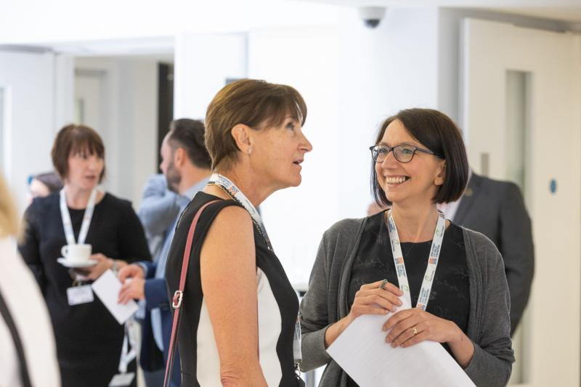

Staff Charter
“We are committed to the work we do and the ideals, values and charitable purpose of the organisation”

Our Staff Charter supports the behaviours we expect each other to demonstrate to achieve the organisation’s values of Ambition, Expertise, Independence and Collaboration
Teamwork  - We pitch in to help each other and recognise each other’s workloads  - We commit to the success of the organisation  - We share expertise and learn from each other  - We communicate clearly and appropriately with each other  - We have a sense of humour and recognise the power of smiling!  - We are flexible and responsive to change (both internally and externally) | Empowerment  - We take ownership and responsibility for our work  - We are trusted by the organisation to do our roles and, in return, the organisation should “have our back”  - We take initiative, where appropriate, and we encourage a culture where we feel confident in doing so  - We give each other credit and praise and challenge in an appropriate and constructive manner  - We are involved in change decisions and making change happen  - We positively learn from our mistakes and we aim to create an environment where staff feel they can ask for help  - We take ownership of our personal and professional development
Passion  - We encourage a culture of innovation and creativity: proactively identifying new ideas, income streams and ways of working  - We commit to continuous improvement: simplifying processes and decision making, wherever possible  - We have ambition for all our colleagues to develop and flourish at work  - We display a positive attitude at work  - We celebrate success – we share good news and good examples of work  - We give each other praise and recognition | Integrity  - We commit to acting in a fair way: being open minded, honest and transparent  - We actively listen to our colleagues and respect the views of stakeholders  - We treat colleagues with respect (regardless of role, grade or hierarchy)  - We resolve issues with each other sensitively, consistently and constructively  - We demonstrate our understanding of the impact of our decisions and help to build a sustainable and financially viable organisation

Job Description - Senior Economist
Salary: £40,000 – £50,000 per annum, depending on experience and location
Location: Leicester / London / Flexible
Contract: Full-time role / Flexibility or part-time considered.

Main Purpose
This is a key role within Learning and Work Institute, with responsibility for leading quantitative analyses in the fields of employment, labour markets, education and skills. This role will have a particular focus on designing and leading high quality impact evaluations, helping us generate evidence on what works in employment and skills to deliver better outcomes. The ideal candidate will bring a strong understanding of labour market economics, advanced econometric skills, a track record of designing and delivering projects, and an interest in the policy context for learning, skills and employment.

Duties and Responsibilities
- Design and deliver high quality research and policy projects focused on employment, the labour market and skills.
- Support the development of economic thinking within L&W, providing internal and external expertise on economic and labour market policy, and contributing to our evaluation of employment and skills programmes.
- Develop L&W’s economic analysis capabilities, particularly in relation to the evaluation and quantitative analysis of labour market programmes, and the use of a range of relevant data sources and creative analysis to understand the labour market and the future of work.
- Proactively provide advice, support and guidance to colleagues, and ensuring that robust findings and recommendations are presented with clarity and precision.
- Support income generation, by generating project ideas, leading the development of proactive proposals and responses to tenders, and providing input into project proposals with a significant economics or analytical component.
- Disseminate research findings through written reports, media articles, blogs and presentations. Communicate the work of L&W through print and broadcast media.
- Develop and maintain effective relationships and networks - including national and local government, trusts and foundations, and other research centres and thinktanks – and represent L&W at events and external meetings.
- Manage research managers and economic researchers, as required.
- Demonstrate a commitment to equality of opportunity and a positive, open and collaborative approach in line with L&W’s core values and Staff Charter.
- Travel and occasional overnight stays will be required.

Person Specification

 | Essential/ Desirable
Degree or equivalent level qualification in economics, statistics, research or social science degree with significant statistics element, or equivalent experience. | E
Strong understanding of labour market economics and labour market policy. | E
Experience of designing and analysing quantitative research projects, and experimental or quasi-experimental evaluation. | E
Experience of working with administrative and survey data sets in the areas of employment and skills. | E
Well-developed skills in designing and analysing value for money and/or economic evaluation e.g. cost-benefit analysis. | E
Experience of conducting econometric analysis, including multiple linear regression and modelling. | E
Knowledge and experience of using analytical software packages such as SPSS, R and/or STATA | E
Excellent written and spoken communication skills, with proven ability to communicate complex ideas in a clear and compelling way to a variety of audiences. | E
Excellent networking skills with experience of building strong relationships with a wide range of stakeholders. | D
Demonstrable skills in generating project ideas and writing proposals, with a proven track record of securing funding. | D
Proven track record in delivering high quality analytical projects to time and budget. | E
Well-developed people management skills with experience in supporting professional and personal development. | D

L&W works across the UK. Our work in Wales is led by a Cardiff based team, but all staff are required to follow the guidance set out in our Welsh language scheme when working in Wales.
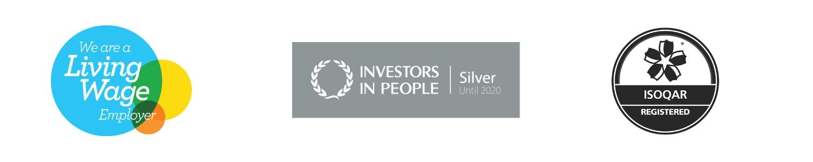

Terms of appointment

Contract: Full-time role / Flexibility or part-time considered

Remuneration: £40,000 – £50,000 per annum, depending on experience and location.

Location: This post is based Leicester / London / Flexible. Travel and occasional overnight stays will be required.

Pension: This post is pensionable. L&W offers the Local Government Pension Scheme. Further Information can be found at https://www.lgpsmember.org/

Annual Leave Entitlement: The annual leave allowance is 25 days a year, in addition to 8 Bank Holidays and 6 grace days.
L&W offer a variety of employee benefits to staff. The details depend on the exact legacy T&Cs on which an individual is employed. However, in summary, L&W’s benefits package includes the following:
- Contractual Annual leave entitlement & public holidays or Grace days (significantly above statutory minimum)
- Pension
- Season Ticket Loan
- Salary Advances (for exceptional circumstances)
- Occupational Sick Pay entitlement (well above statutory minimum)
- Flexible working practices / working from home
- Reasonable adjustments for those with disabilities
- EDS – Employee Development Scheme
- Employee Assistance Programme (EAP) through Health Assured – Counselling; financial advice etc.
- Eye Test Support
- Study Support for relevant Professional/Academic Qualifications
- Occupational Maternity Leave & Pay (above statutory minimum)
- Time off for Ante-Natal appointments
- Compassionate leave
- Paid leave to care for a sick person
- Time off for Trade Union duties
- Time off for Public duties
- Childcare Vouchers or Financial Childcare support
- Cycle to Work Scheme
- Redundancy Pay
- Paternity Pay

How to apply
- Applicants should submit a CV and a separate personal statement demonstrating how they meet the essential criteria for the role. Your personal statement should be no more than two pages long. A CV setting out your career history, with responsibilities and achievements
- Your current remuneration package and salary expectations
- Details of two referees (referees will not be contacted before final interviews without your express permission). The successful candidate will be subject to final references before an appointment can be formally offered
- Your application must be submitted via the GatenbySanderson website at www.gatenbysanderson.com. The reference for this role is GSe75549
Our recruitment partners in this programme are GatenbySanderson who will acknowledge your application and advise you of the outcome of your application.
Following your application, a meeting will be held to determine a final shortlist of candidates who will progress to the final panel interview process. You will be advised of the format, date and timing for the final panel interview in advance.
Where possible, GatenbySanderson will provide feedback. However, depending on the volume of applications it may not always be possible to provide feedback to all candidates.
The closing date for applications is 5 July 2021

Indicative timetable
Closing date for applications | 5 July 2021
Final Panel interview | w/c 12 July 2021

Queries
If you have any queries about the role or the selection process, please contact our advising consultants at GatenbySanderson Enfys Evans or Hilda Gjika on 020 7426 3996 / enfys.evans@gatenbysanderson.com

