Rt Hon Mel Stride MP
Secretary of State
Department for Work and Pensions
Caxton House
Tothill Street
London SW1H 9NA

Date TBC

Dear Secretary of State,

We are writing to call on you to exempt young adult carers from the 21 hour rule in the benefit system (also known as the full time education rule), which means that they cannot claim Carer’s Allowance if they study for more than 21 hours per week.

Young adult carers are young people aged 16-24 who provide unpaid care to someone, usually a family member, on a regular basis. The 2021 Census identified 272,731 young adult carers aged 16-24 in England and Wales, the equivalent of around 1 in 21 young people. Of these, around 37,000 young people provide over 50 hours of care each week. It’s estimated that these young people provide over £3.5bn of unpaid care per year.

Young adult carers often give up their childhoods to care for others. Yet, through no fault of their own, they consistently miss out on opportunities in learning and work:

- Young adult carers have significantly lower educational attainment at GCSE, the equivalent to nine grades lower overall than their peers.
- 24% of young adult carers in school say they cannot afford to go to college or university.
- Young adult carers are three times as likely to be NEET (not in education, employment or training) compared to other young people.
- Young adult carers are 4 times more likely to drop out of college and university than a student without caring responsibilities.
- Young adult carers are 38% less likely to gain a degree qualification than non-carers. This inequality is magnified for young people who provide high levels of care, with those who care for 35+ hours per week 86% less likely to gain a degree.
Current benefit rules mean young adult carers cannot claim Carer’s Allowance if they study for more than 21 hours per week. This limits their ability to study the Government’s ‘gold standard’ qualifications like A levels and T levels, limiting their choices compared to other young people. In turn, that risks limiting their chances to progress to higher education and their long-term career prospects.

On this basis, we are calling on you to exempt young adult carers from the 21 hour rule in the benefit system (also known as the full time education rule), which means that they cannot claim Carer’s Allowance if they study for more than 21 hours per week.

No young adult carer should miss out on learning because they care for their families. This simple policy change would make a significant difference in opening up ‘gold standard’ opportunities, such as T-levels and A-levels, for young adult carers who have missed out on so much. The Scottish Government has recently announced that this change will be implemented from 2024. Urgent action should be taken to ensure that young adult carers in England and Wales are not left behind.

Our calculations show that the cost of providing Carer’s Allowance to all eligible young adult carers aged 16-24 in further education (up to and including level 3) is estimated at £54m per year. To extend this to all young adult carers, studying at any level, the cost is estimated at £85m per year.

At the very least, 16-18 year olds should be exempt from the rule, as this would enable young adult carers to study the ‘gold standard’ T-levels and A-levels. For young adult carers aged 16-18 the cost is estimated at £31m per year.

Implementing this simple policy change would have long-lasting educational and economic benefits for young adult carers and the country. It will enable more young people with caring responsibilities to study, to complete their courses and to gain ‘flagship’ qualifications such as T levels, improving their employment prospects and earnings as a result.

Together, the undersigned, are committed to ensuring that young adult carers get the opportunities they need and deserve.

Please contact Nicola.aylward@learningandwork.org.uk to discuss this proposed policy change.

Yours sincerely,

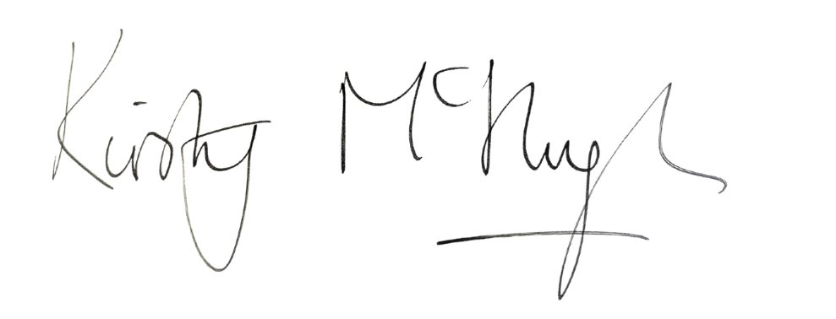

Stephen Evans Kirsty McHugh
Chief Executive Chief Executive Officer
L&W Carers Trust

[List of signatories to be added: name, role, organisation]

