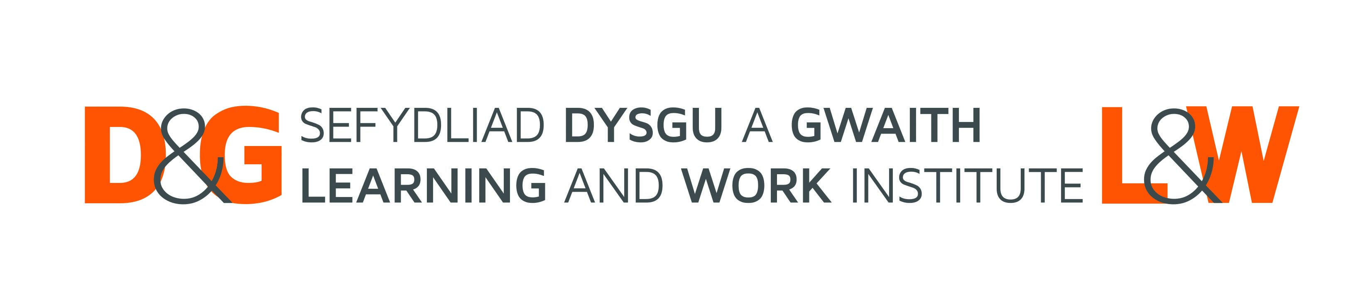
Welsh Government: Skills Audit for Wales
We want your view on skills needs in Wales.

Part 1: Uploading relevant evidence
Would you like to share any evidence about the skills needs and drivers in Wales? As a quick reminder, we’re interested in evidence that will help us understand the below themes:
- The current and future skills needs in Wales, including key sectors and occupations
- How the current skills system meets skills needs, including how the skills system meets employers' needs
- What the key drivers of the labour market are now and in the future, and their impact on the skills that are needed.
- Cross-cutting skills that apply across sectors and occupations, including whether these are more prevalent in certain occupations or sectors
- How skills needs vary regionally, including the anticipated impacts of local economic development plans on skills requirements.

Please upload your evidence, share a link to it and/or tell us about the evidence in the survey

Part 2: Optional questions
The following questions are optional, and aim to explore more about your views on the skills needs, gaps, and drivers in Wales.

Understanding skills needs in Wales
What are the most important current and future skills needs in Wales?
You may wish to consider:
- Specific occupations, sectors, regions or workforce groups.
- Whether these needs are short-term (0–3 years), medium-term (3–5 years) or longer-term (5+ years).
- Technical, basic (literacy/numeracy/digital), employability, leadership or management skills.
- Any evidence or data that supports your views.

Where do you see gaps or mismatches between skills supply and demand? This refers to the balance between the skills available and upcoming in the workforce and the skills that employers and the economy need
You may wish to consider:
- Occupations, sectors or regions where employers struggle to recruit people with the right skills.
- Occupations, sectors or regions where employer’s Welsh Language requirements lead to a struggle to recruit or access relevant training.
- Areas where individuals' skills are underused or do not match labour market needs.
- Factors contributing to skills shortages, gaps or mismatches.
- Whether these issues are current, emerging or likely to change in the future.

What impact are current or future skills gaps, shortages or mismatches having, or likely to have in the future?
You may wish to consider impacts on:
- Recruitment and retention.
- Productivity, growth or innovation.
- Delivery of public services.
- Workforce development and progression.
- Individuals, communities or particular groups of people.
- Wales' future economic and social wellbeing.

Trends and priorities

What do you see as the key trends and drivers in the labour market affecting skills needs in Wales?
You may want to consider the following:
- To what extent are these general needs or specific to a particular area or sector?
- To what extent are these short-term (0-3 years), medium-term- (3-5 years), and/or longer-term (5+ years) trends?

What are the key priorities, opportunities or challenges in your sector or policy area that you would like the findings of this research to inform??

